**JPA vs Hibernate vs Spring Data JPA - Complete Comparison**

**Overview**

This document provides a comprehensive comparison between Java Persistence API (JPA), Hibernate, and Spring Data JPA, explaining their relationships, differences, and practical usage with code examples.

**Table of Contents**

1. [Understanding Each Technology](https://claude.ai/chat/a8329b13-e780-43c2-8673-e763dcb34741#understanding-each-technology)
2. [Architecture and Relationships](https://claude.ai/chat/a8329b13-e780-43c2-8673-e763dcb34741#architecture-and-relationships)
3. [Code Comparison Examples](https://claude.ai/chat/a8329b13-e780-43c2-8673-e763dcb34741#code-comparison-examples)
4. [Detailed Feature Comparison](https://claude.ai/chat/a8329b13-e780-43c2-8673-e763dcb34741#detailed-feature-comparison)
5. [When to Use What](https://claude.ai/chat/a8329b13-e780-43c2-8673-e763dcb34741#when-to-use-what)
6. [Best Practices](https://claude.ai/chat/a8329b13-e780-43c2-8673-e763dcb34741#best-practices)

**Understanding Each Technology**

**Java Persistence API (JPA)**

**JPA** is a **specification** (JSR 338) that defines how to persist, read, and manage data from Java objects to relational databases.

**Key Characteristics:**

* **Specification, not implementation**: JPA is just a set of interfaces and annotations
* **Vendor-neutral**: Provides a standard way to work with ORM tools
* **JSR 338 Standard**: Officially standardized by Java Community Process
* **No concrete implementation**: Requires an implementation provider

**Core JPA Components:**

* **EntityManager**: Interface for database operations
* **Persistence Context**: Environment where entities are managed
* **JPQL**: Java Persistence Query Language
* **Annotations**: @Entity, @Table, @Id, @Column, etc.

// Pure JPA Example

@Entity

@Table(name = "employees")

public class Employee {

@Id

@GeneratedValue(strategy = GenerationType.IDENTITY)

private Integer id;

@Column(name = "first_name")

private String firstName;

@Column(name = "last_name")

private String lastName;

// Getters and setters

}

**Hibernate**

**Hibernate** is a **concrete implementation** of the JPA specification and also provides additional features beyond JPA.

**Key Characteristics:**

* **ORM Framework**: Object-Relational Mapping tool
* **JPA Implementation**: Implements all JPA specifications
* **Extended Features**: Provides features beyond JPA standard
* **Mature Framework**: Been around since 2001
* **Hibernate-specific APIs**: SessionFactory, Session, Query, etc.

**Hibernate Components:**

* **SessionFactory**: Factory for creating Session objects
* **Session**: First-level cache and transaction management
* **Transaction**: Database transaction management
* **HQL**: Hibernate Query Language (superset of JPQL)
* **Criteria API**: Programmatic query building

// Hibernate-specific Example

public class EmployeeDAO {

private SessionFactory sessionFactory;

public void saveEmployee(Employee employee) {

Session session = sessionFactory.openSession();

Transaction tx = null;

try {

tx = session.beginTransaction();

session.save(employee);

tx.commit();

} catch (HibernateException e) {

if (tx != null) tx.rollback();

throw e;

} finally {

session.close();

}

}

}

**Spring Data JPA**

**Spring Data JPA** is a **higher-level abstraction** that simplifies JPA usage by reducing boilerplate code.

**Key Characteristics:**

* **Abstraction Layer**: Built on top of JPA implementations
* **No JPA Implementation**: Uses existing JPA providers (like Hibernate)
* **Boilerplate Reduction**: Eliminates repetitive DAO code
* **Convention over Configuration**: Follows naming conventions
* **Automatic Transaction Management**: Handles transactions automatically

**Spring Data JPA Components:**

* **Repository Interfaces**: JpaRepository, CrudRepository, PagingAndSortingRepository
* **Query Methods**: Automatic query generation from method names
* **Custom Queries**: @Query annotation for custom JPQL/SQL
* **Transaction Management**: @Transactional annotation

// Spring Data JPA Example

@Repository

public interface EmployeeRepository extends JpaRepository<Employee, Integer> {

// No implementation needed - Spring generates it automatically

List<Employee> findByFirstName(String firstName);

List<Employee> findByLastNameContaining(String lastName);

}

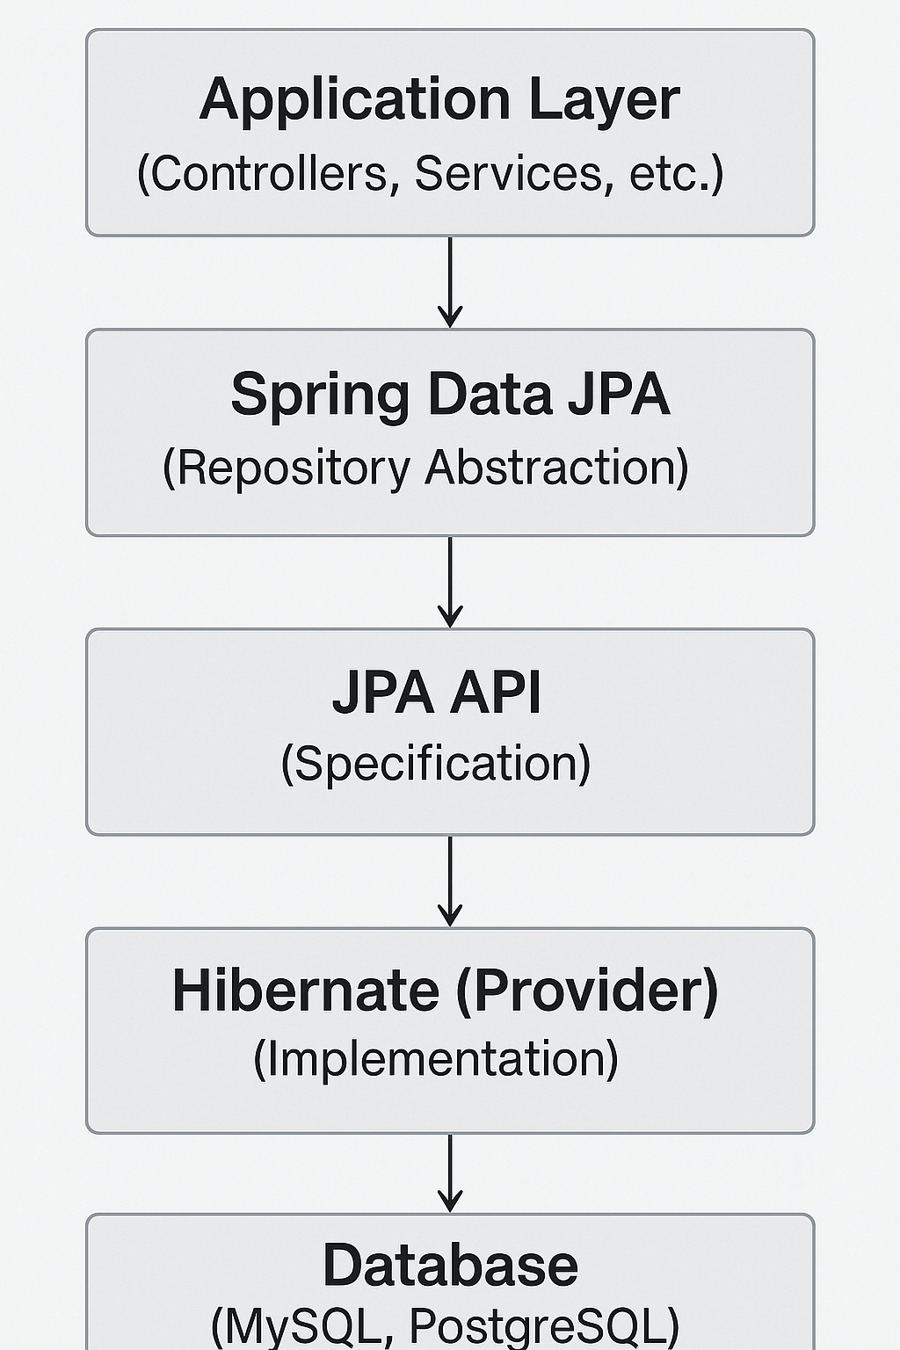

**Relationship Summary:**

* **JPA**: Defines the contract (interfaces and annotations)
* **Hibernate**: Implements the JPA contract + additional features
* **Spring Data JPA**: Provides a higher-level abstraction over JPA

**Code Comparison Examples**

Let's see how the same operations are implemented across all three approaches:

**1. Entity Definition**

All three use the same entity definition since they all follow JPA annotations:

@Entity

@Table(name = "employees")

public class Employee {

@Id

@GeneratedValue(strategy = GenerationType.IDENTITY)

private Integer id;

@Column(name = "first_name")

private String firstName;

@Column(name = "last_name")

private String lastName;

@Column(name = "salary")

private BigDecimal salary;

// Constructors, getters, and setters

public Employee() {}

public Employee(String firstName, String lastName, BigDecimal salary) {

this.firstName = firstName;

this.lastName = lastName;

this.salary = salary;

}

// Getters and setters...

}

**2. CREATE Operation**

**Pure JPA Approach:**

@Repository

public class EmployeeJpaDAO {

@PersistenceContext

private EntityManager entityManager;

@Transactional

public void addEmployee(Employee employee) {

entityManager.persist(employee);

}

}

**Hibernate Approach:**

@Repository

public class EmployeeHibernateDAO {

@Autowired

private SessionFactory sessionFactory;

public Integer addEmployee(Employee employee) {

Session session = sessionFactory.openSession();

Transaction tx = null;

Integer employeeID = null;

try {

tx = session.beginTransaction();

employeeID = (Integer) session.save(employee);

tx.commit();

} catch (HibernateException e) {

if (tx != null) tx.rollback();

e.printStackTrace();

} finally {

session.close();

}

return employeeID;

}

}

**Spring Data JPA Approach:**

// Repository Interface

@Repository

public interface EmployeeRepository extends JpaRepository<Employee, Integer> {

// No implementation needed!

}

// Service Class

@Service

public class EmployeeService {

@Autowired

private EmployeeRepository employeeRepository;

@Transactional

public Employee addEmployee(Employee employee) {

return employeeRepository.save(employee);

}

}

**3. READ Operations**

**Pure JPA Approach:**

@Repository

public class EmployeeJpaDAO {

@PersistenceContext

private EntityManager entityManager;

public Employee findById(Integer id) {

return entityManager.find(Employee.class, id);

}

public List<Employee> findAll() {

return entityManager.createQuery("SELECT e FROM Employee e", Employee.class)

.getResultList();

}

public List<Employee> findByFirstName(String firstName) {

return entityManager.createQuery(

"SELECT e FROM Employee e WHERE e.firstName = :firstName", Employee.class)

.setParameter("firstName", firstName)

.getResultList();

}

}

**Hibernate Approach:**

@Repository

public class EmployeeHibernateDAO {

@Autowired

private SessionFactory sessionFactory;

public Employee findById(Integer id) {

Session session = sessionFactory.openSession();

Transaction tx = null;

Employee employee = null;

try {

tx = session.beginTransaction();

employee = session.get(Employee.class, id);

tx.commit();

} catch (HibernateException e) {

if (tx != null) tx.rollback();

e.printStackTrace();

} finally {

session.close();

}

return employee;

}

public List<Employee> findAll() {

Session session = sessionFactory.openSession();

Transaction tx = null;

List<Employee> employees = null;

try {

tx = session.beginTransaction();

employees = session.createQuery("FROM Employee", Employee.class).list();

tx.commit();

} catch (HibernateException e) {

if (tx != null) tx.rollback();

e.printStackTrace();

} finally {

session.close();

}

return employees;

}

}

**Spring Data JPA Approach:**

@Repository

public interface EmployeeRepository extends JpaRepository<Employee, Integer> {

// Built-in methods (no implementation needed):

// findById(Integer id)

// findAll()

// save(Employee employee)

// deleteById(Integer id)

// Custom query methods (auto-generated):

List<Employee> findByFirstName(String firstName);

List<Employee> findByLastName(String lastName);

List<Employee> findByFirstNameAndLastName(String firstName, String lastName);

List<Employee> findByFirstNameContaining(String firstName);

List<Employee> findBySalaryGreaterThan(BigDecimal salary);

// Custom queries using @Query annotation:

@Query("SELECT e FROM Employee e WHERE e.salary > :minSalary")

List<Employee> findHighSalaryEmployees(@Param("minSalary") BigDecimal minSalary);

@Query(value = "SELECT * FROM employees WHERE salary BETWEEN ?1 AND ?2",

nativeQuery = true)

List<Employee> findBySalaryRange(BigDecimal minSalary, BigDecimal maxSalary);

}

**4. UPDATE Operations**

**Pure JPA Approach:**

@Transactional

public void updateEmployee(Employee employee) {

entityManager.merge(employee);

}

**Hibernate Approach:**

public void updateEmployee(Employee employee) {

Session session = sessionFactory.openSession();

Transaction tx = null;

try {

tx = session.beginTransaction();

session.update(employee);

tx.commit();

} catch (HibernateException e) {

if (tx != null) tx.rollback();

e.printStackTrace();

} finally {

session.close();

}

}

**Spring Data JPA Approach:**

@Transactional

public Employee updateEmployee(Employee employee) {

return employeeRepository.save(employee); // save() handles both insert and update

}

**5. DELETE Operations**

**Pure JPA Approach:**

@Transactional

public void deleteEmployee(Integer id) {

Employee employee = entityManager.find(Employee.class, id);

if (employee != null) {

entityManager.remove(employee);

}

}

**Hibernate Approach:**

public void deleteEmployee(Integer id) {

Session session = sessionFactory.openSession();

Transaction tx = null;

try {

tx = session.beginTransaction();

Employee employee = session.get(Employee.class, id);

if (employee != null) {

session.delete(employee);

}

tx.commit();

} catch (HibernateException e) {

if (tx != null) tx.rollback();

e.printStackTrace();

} finally {

session.close();

}

}

**Spring Data JPA Approach:**

@Transactional

public void deleteEmployee(Integer id) {

employeeRepository.deleteById(id);

}

**Detailed Feature Comparison**

| **Feature** | **JPA** | **Hibernate** | **Spring Data JPA** |
| --- | --- | --- | --- |
| **Type** | Specification | Implementation | Abstraction Layer |
| **Boilerplate Code** | High | High | Very Low |
| **Learning Curve** | Medium | High | Low |
| **Transaction Management** | Manual | Manual | Automatic |
| **Query Methods** | Manual JPQL | Manual HQL | Auto-generated |
| **Custom Queries** | @NamedQuery | HQL/SQL | @Query annotation |
| **Caching** | Basic | Advanced | Inherited from JPA provider |
| **Batch Operations** | Limited | Extensive | Limited |
| **Lazy Loading** | Standard | Advanced | Standard |
| **Vendor Independence** | High | Low | High |
| **Performance Tuning** | Limited | Extensive | Limited |
| **Community Support** | Good | Excellent | Good |

**When to Use What**

**Use Pure JPA When:**

* You need **vendor independence** across different JPA providers
* Working with **Java EE** environments
* You want to **minimize dependencies**
* You need **fine-grained control** over persistence operations
* Working with **legacy systems** that require JPA compatibility

**Use Hibernate When:**

* You need **advanced features** beyond JPA specification
* **Performance optimization** is critical
* You require **complex batch operations**
* You need **advanced caching strategies**
* Working with **legacy Hibernate applications**
* You need **custom data types** or **user types**

**Use Spring Data JPA When:**

* You're building **Spring/Spring Boot** applications
* You want to **reduce boilerplate code**
* **Rapid development** is a priority
* You need **automatic transaction management**
* You want **convention-over-configuration** approach
* You're building **CRUD-heavy applications**
* You need **repository pattern** implementation

**Best Practices**

**General Guidelines:**

1. **Choose Based on Requirements**:
   * **Rapid Development**: Spring Data JPA
   * **Advanced Features**: Hibernate
   * **Vendor Independence**: Pure JPA
2. **Combine Approaches**:
3. @Repository
4. public interface EmployeeRepository extends JpaRepository<Employee, Integer> {
5. // Spring Data JPA methods
6. List<Employee> findByFirstName(String firstName);
8. // Custom implementation when needed
9. List<Employee> findEmployeesWithComplexCriteria(EmployeeSearchCriteria criteria);
10. }
11. @Repository
12. public class EmployeeRepositoryImpl {
13. @PersistenceContext
14. private EntityManager entityManager;
16. public List<Employee> findEmployeesWithComplexCriteria(EmployeeSearchCriteria criteria) {
17. // Use pure JPA or Hibernate for complex queries
18. CriteriaBuilder cb = entityManager.getCriteriaBuilder();
19. CriteriaQuery<Employee> query = cb.createQuery(Employee.class);
20. // Complex criteria building...
21. return entityManager.createQuery(query).getResultList();
22. }
23. }
24. **Transaction Management**:
25. @Service
26. @Transactional
27. public class EmployeeService {
28. // All methods are transactional by default
30. @Transactional(readOnly = true)
31. public List<Employee> getAllEmployees() {
32. // Read-only transaction for better performance
33. return employeeRepository.findAll();
34. }
36. @Transactional(rollbackFor = Exception.class)
37. public void saveEmployee(Employee employee) {
38. // Rollback on any exception
39. employeeRepository.save(employee);
40. }
41. }
42. **Performance Optimization**:
43. @Repository
44. public interface EmployeeRepository extends JpaRepository<Employee, Integer> {
45. @Query("SELECT e FROM Employee e JOIN FETCH e.department")
46. List<Employee> findAllWithDepartment();
48. @Query("SELECT e FROM Employee e WHERE e.salary > :salary")
49. Page<Employee> findBySalaryGreaterThan(@Param("salary") BigDecimal salary,
50. Pageable pageable);
51. }

**Configuration Examples:**

**Spring Boot with Spring Data JPA:**

# application.properties

spring.datasource.url=jdbc:mysql://localhost:3306/employeedb

spring.datasource.username=root

spring.datasource.password=password

spring.jpa.hibernate.ddl-auto=update

spring.jpa.show-sql=true

spring.jpa.properties.hibernate.dialect=org.hibernate.dialect.MySQL8Dialect

**Pure JPA Configuration:**

@Configuration

@EnableJpaRepositories

public class JpaConfig {

@Bean

public LocalContainerEntityManagerFactoryBean entityManagerFactory() {

LocalContainerEntityManagerFactoryBean em = new LocalContainerEntityManagerFactoryBean();

em.setDataSource(dataSource());

em.setPackagesToScan("com.example.entity");

em.setJpaVendorAdapter(new HibernateJpaVendorAdapter());

return em;

}

@Bean

public PlatformTransactionManager transactionManager() {

JpaTransactionManager transactionManager = new JpaTransactionManager();

transactionManager.setEntityManagerFactory(entityManagerFactory().getObject());

return transactionManager;

}

}

**Conclusion**

* **JPA** provides the foundation and standardization
* **Hibernate** offers powerful implementation with advanced features
* **Spring Data JPA** simplifies development with conventions and automation

Choose the approach that best fits your project requirements, team expertise, and performance needs. In many cases, you can combine approaches within the same application to leverage the strengths of each.